1. This is the EAR FILE

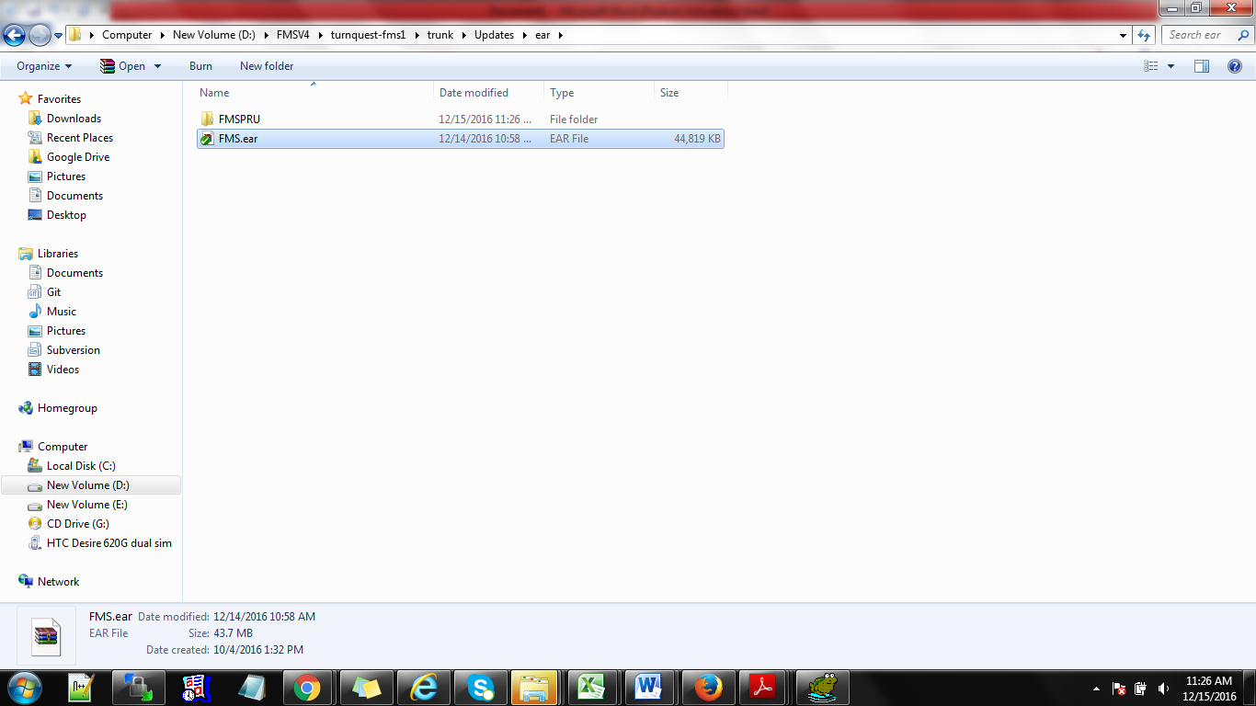

1. In the same folder as the EAR create a main folder( give the folder the name that will be used to access the application eg FMSPRU in this case
2. Inside the main folder, create a subfolder with the same application name.

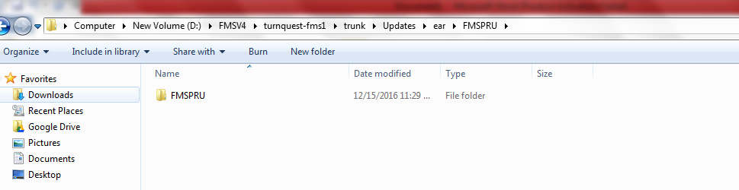

So the folders created now are FMSPRU>>FMSPRU.

1. Click on the EAR file to extract the contents to the first FMSPRU folder.

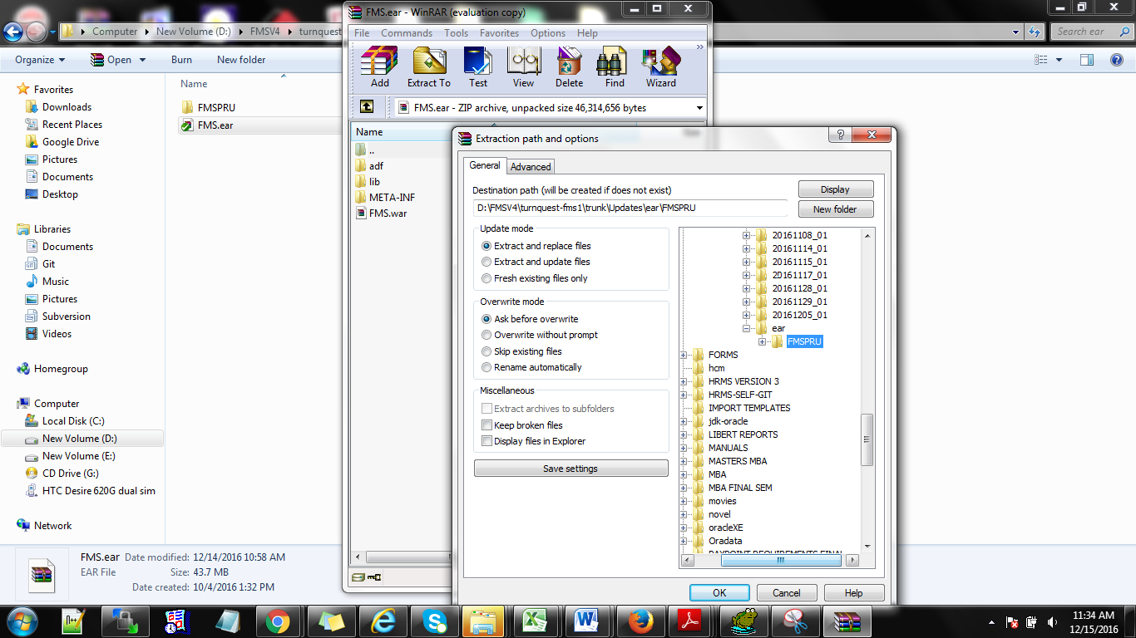

1. The first folder has now the extracted contents

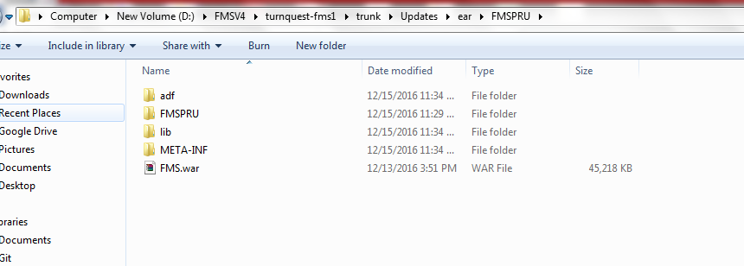

1. Now go ahead and extract the WAR file. The WAR file will be extracted into the 2nd subfolder (FMSPRU>>FMSPRU).

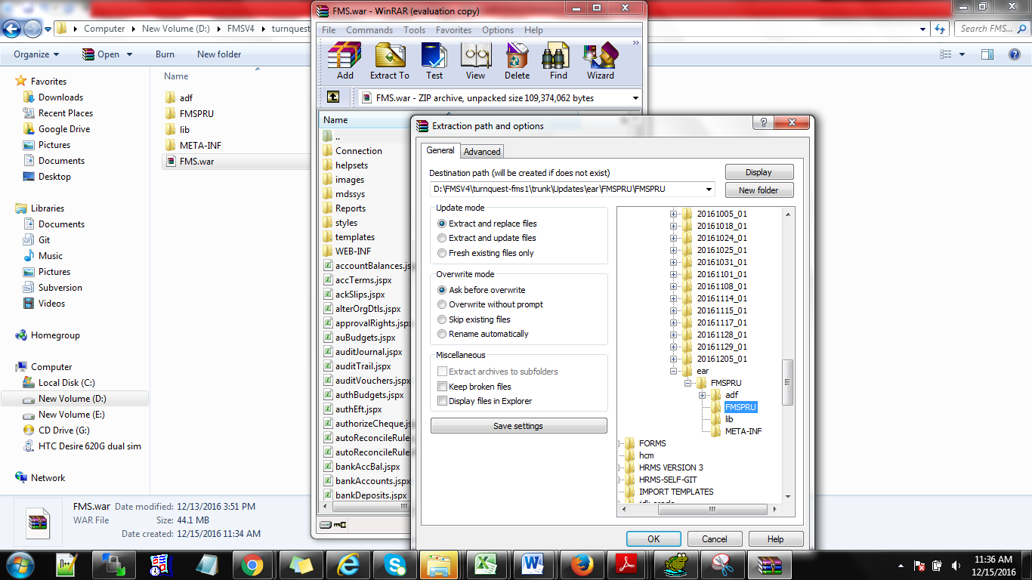

1. Go back to the first FMSPRU folder> go to META INF

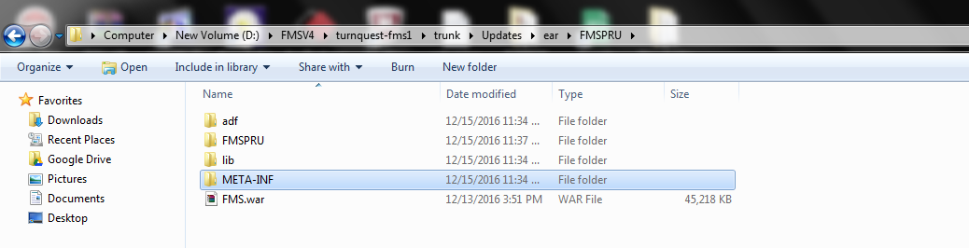

Open application.xml

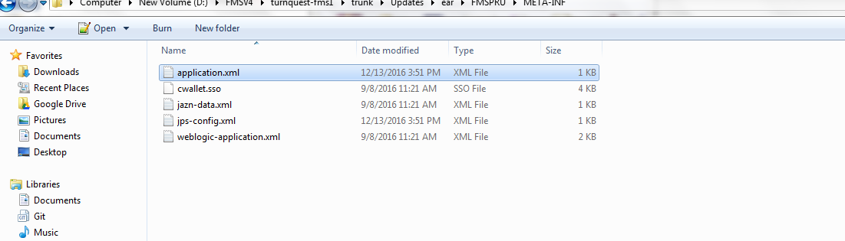

Edit the three areas to the name of the deployment

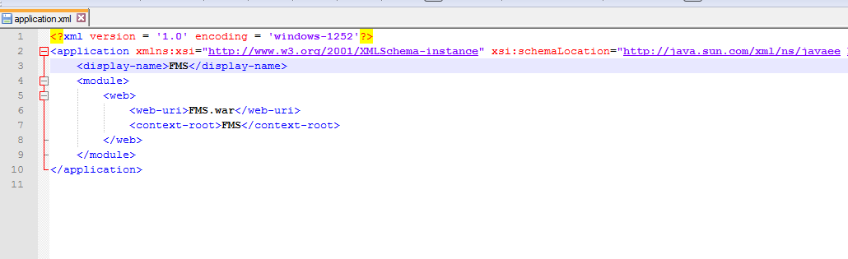

Edited as shown below

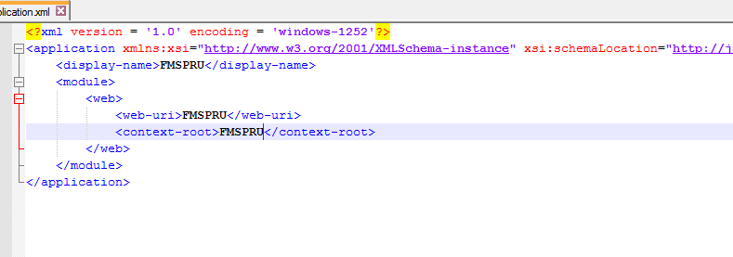

1. Go to the second FMSPRU FOLDER

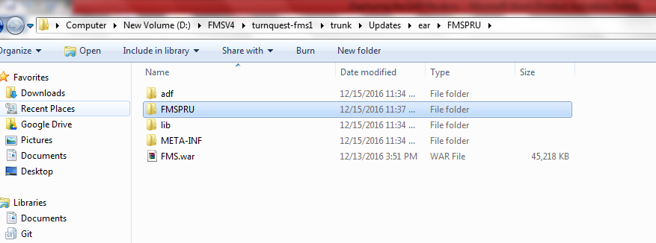

Open WEB INF

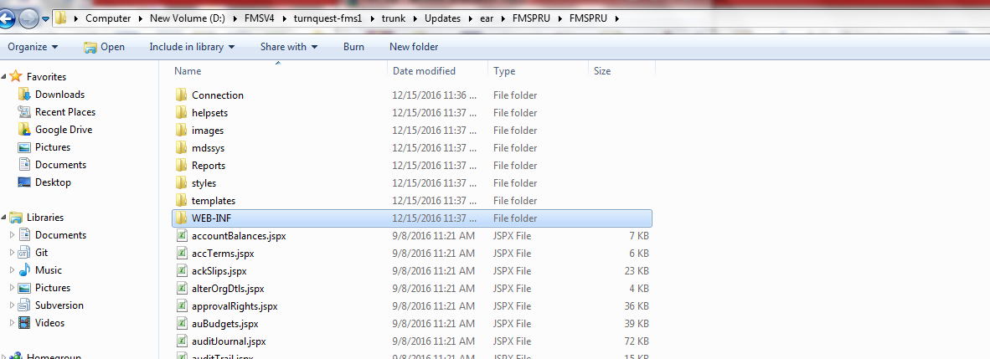

Open the web.xml file

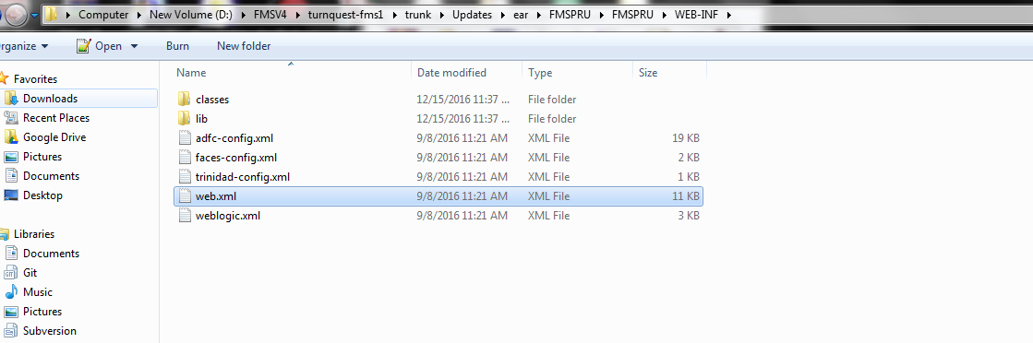

On the web xml file – this is where we tag the datasource name on this three areas

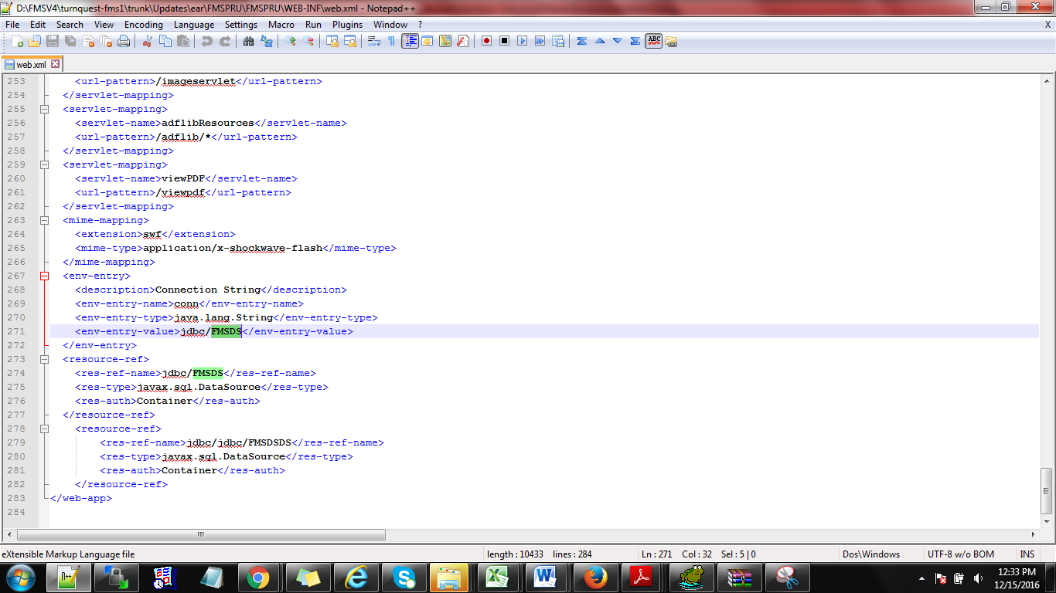

The datasource name given can be FMSPRU as well(**the datasource is the link that allows the application to communicate with the Database)( Links edited)**

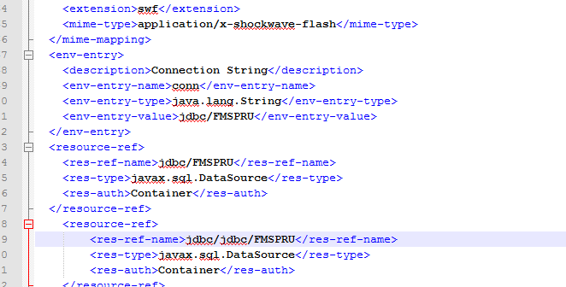

Copy the application into the server (you can use WINSCP)

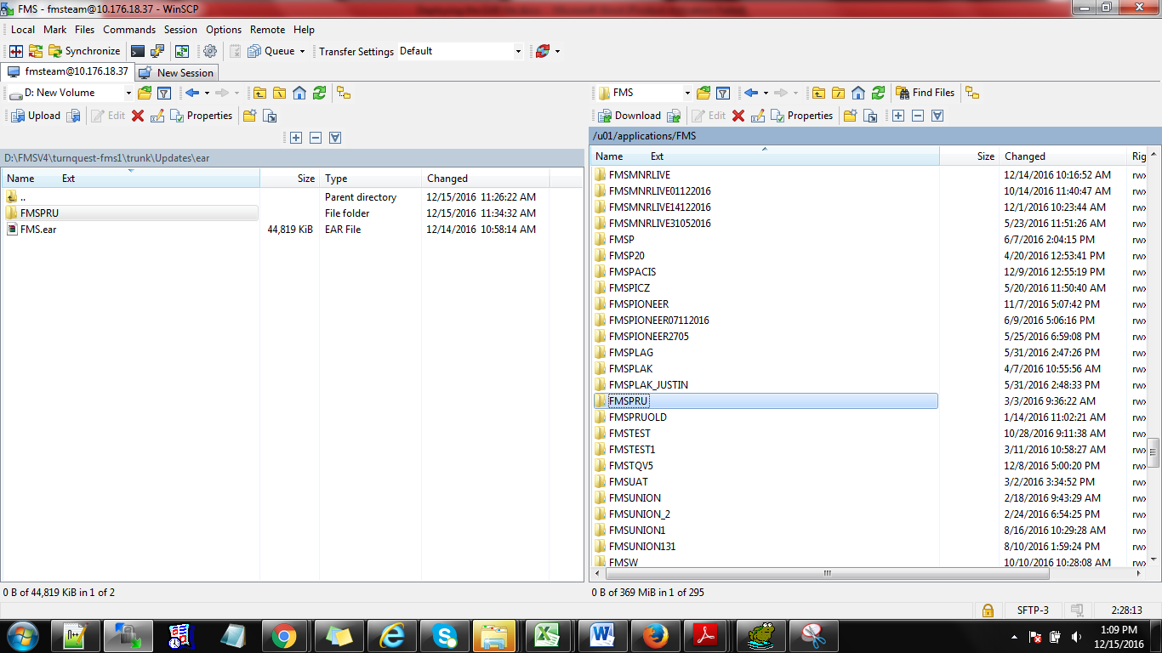

1. Go to the weblogic console>> go to datasources>>new>>generic datasource

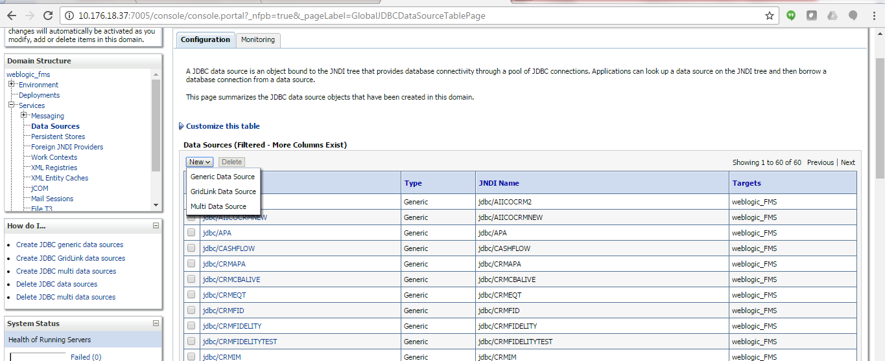

Define the name that we had put in the web.xml above ie the datasource name. Click on Next

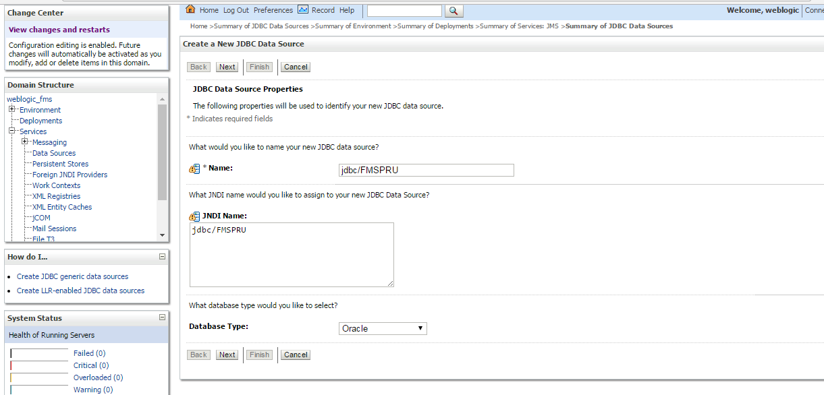

1. The database driver should be Thin for instance connections. Click on next

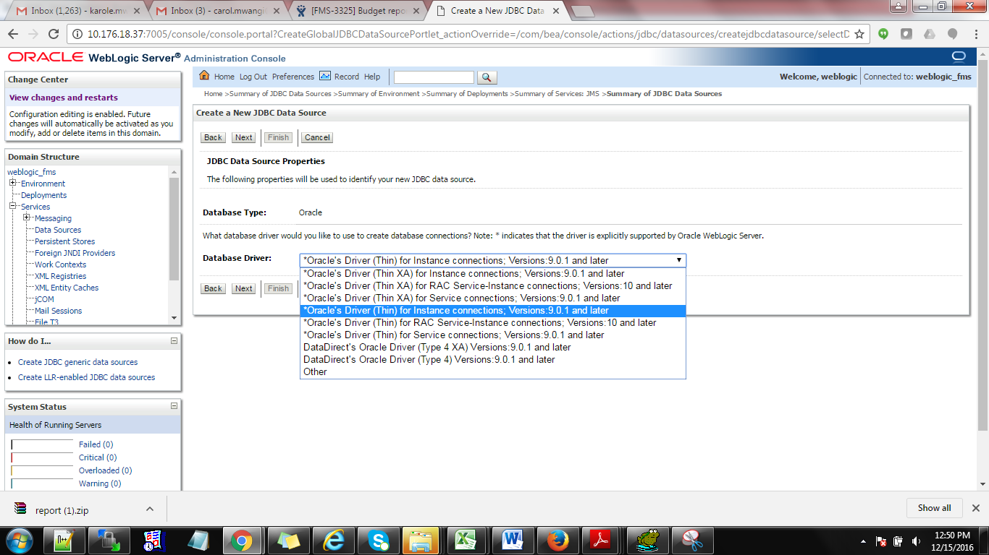

1. Add the details below

**Database name:** Name of DB

**Host name:** Is the DB ID

**Port:** DB port

**Database username:** username used to login into the DB

**Database password**

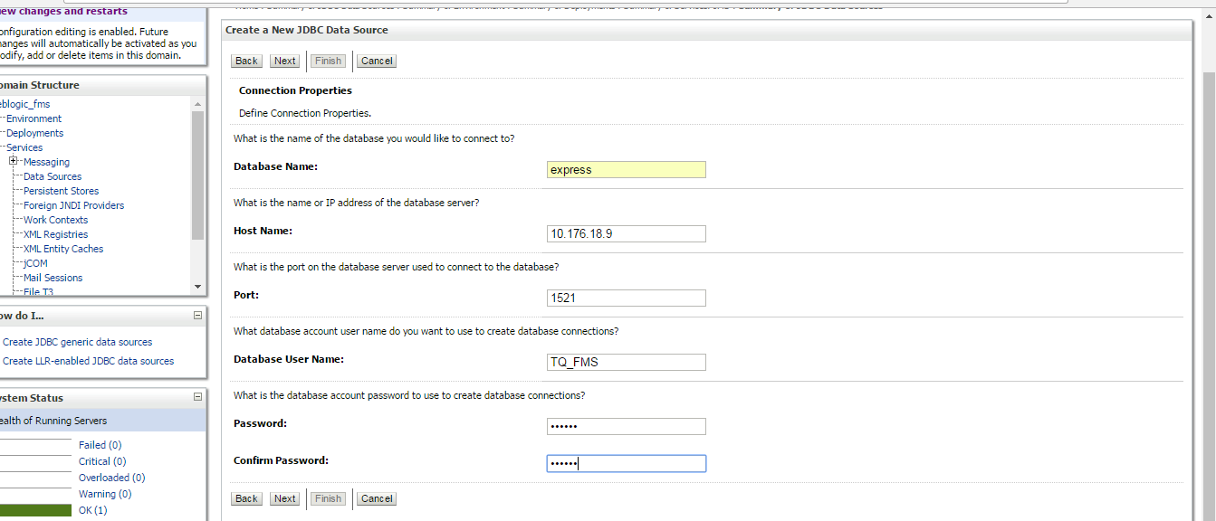

1. Click on next >> click on Test configuration

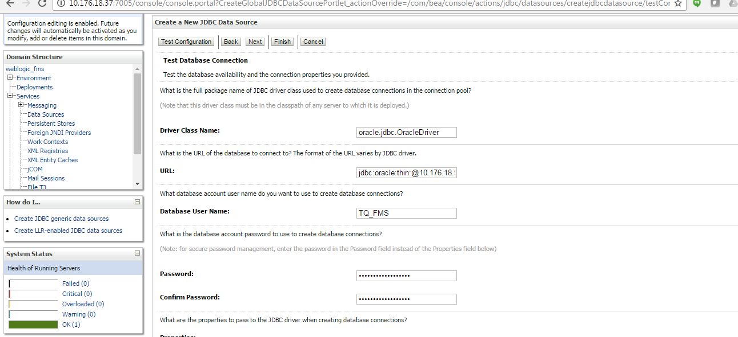

If connection succeeds, click on Next

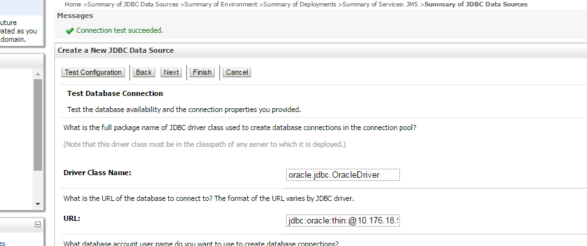

1. Select weblogic server and finish

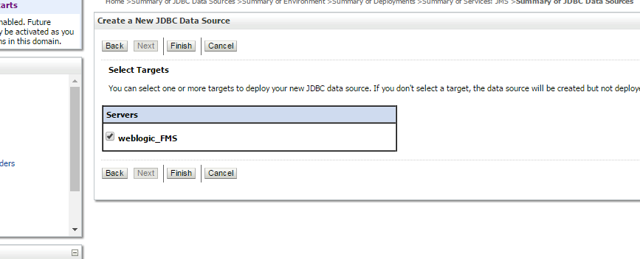

14.The datasource is now created

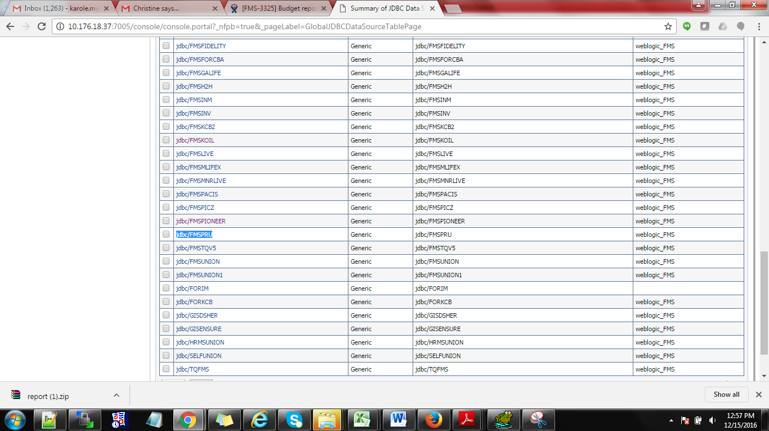

1. Go back to console>>go to deployments>>and click install

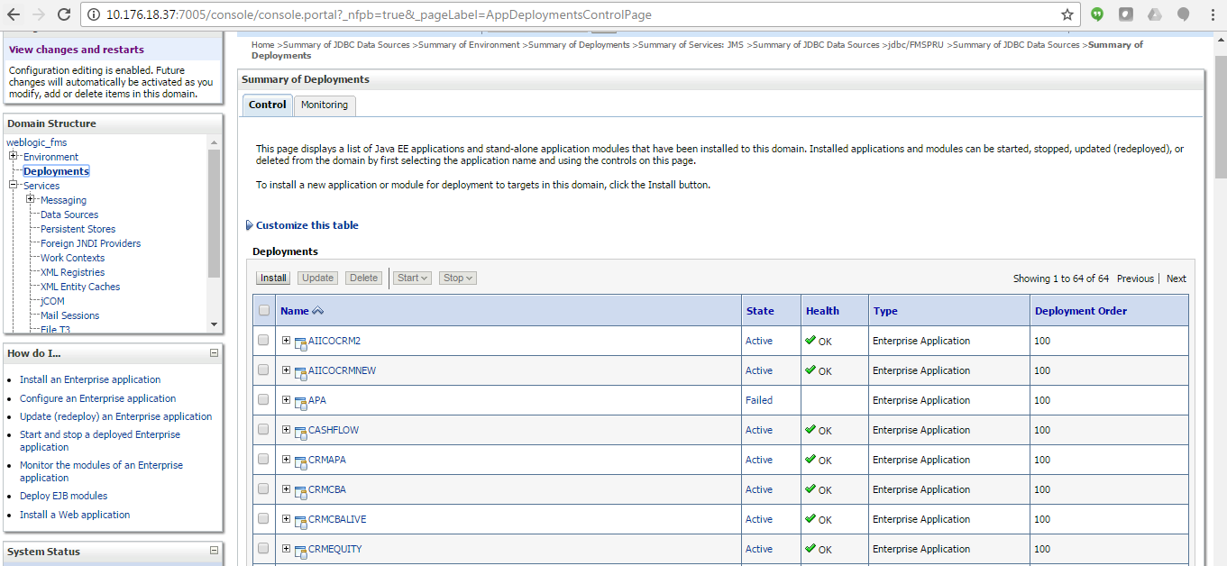

1. Select the deployment you had copied to the server

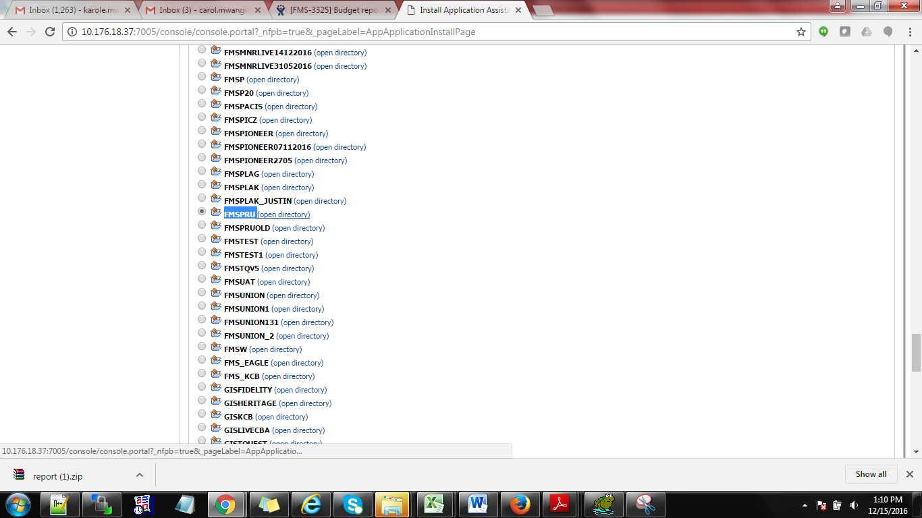

Click on Next

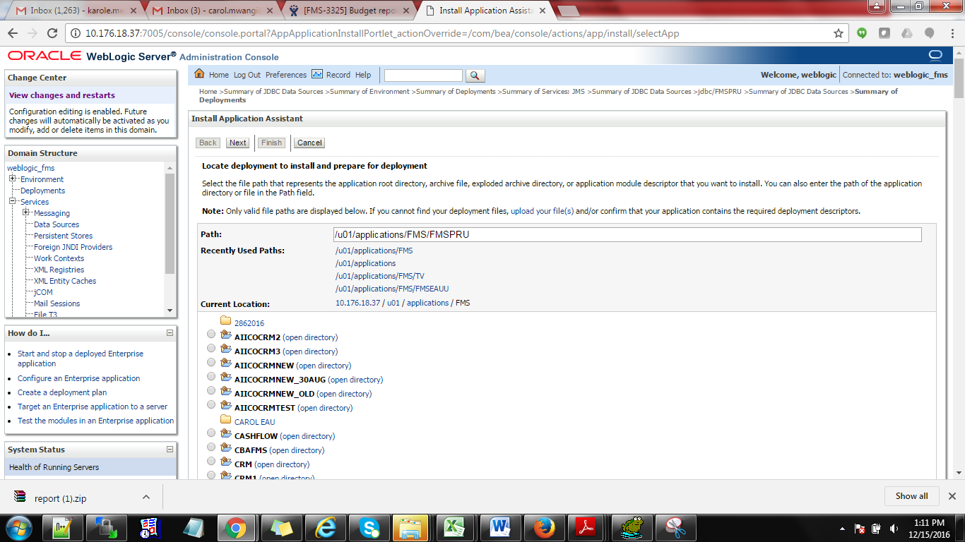

1. Install deployment as an application>>click next

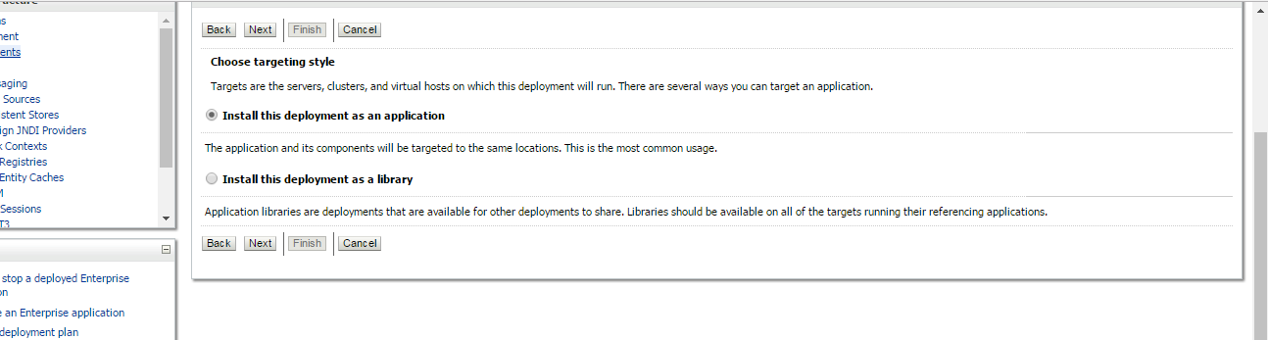

1. Select, I will make deployment accessible from the following location

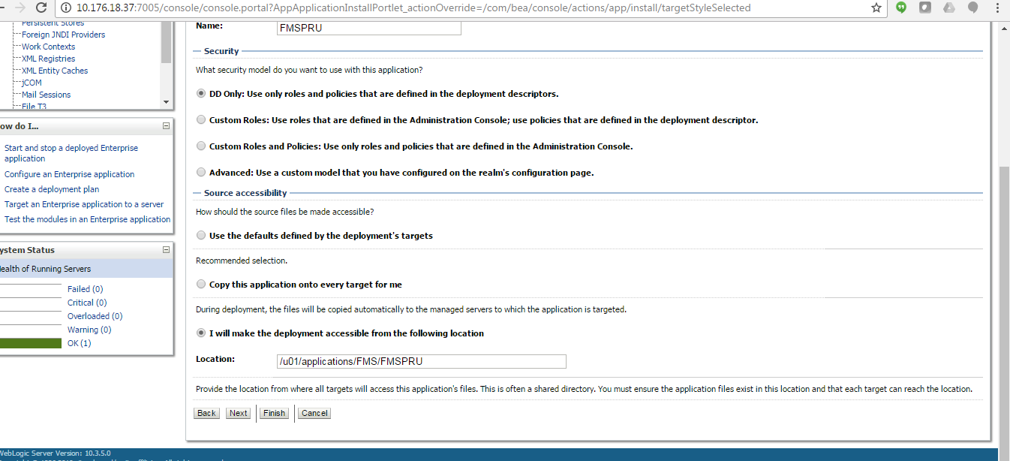

1. Click on Finish

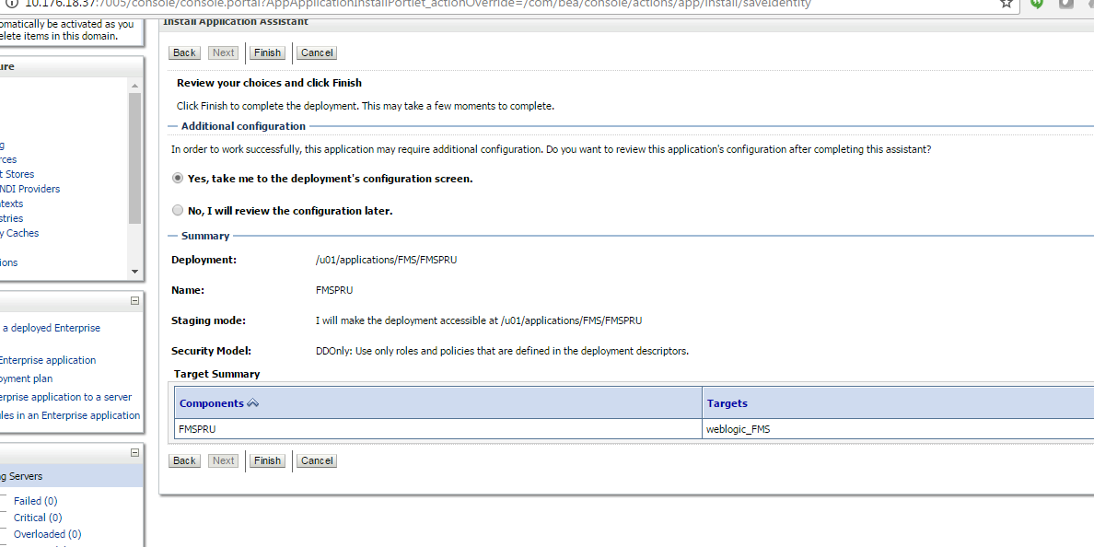

1. Click on SAVE

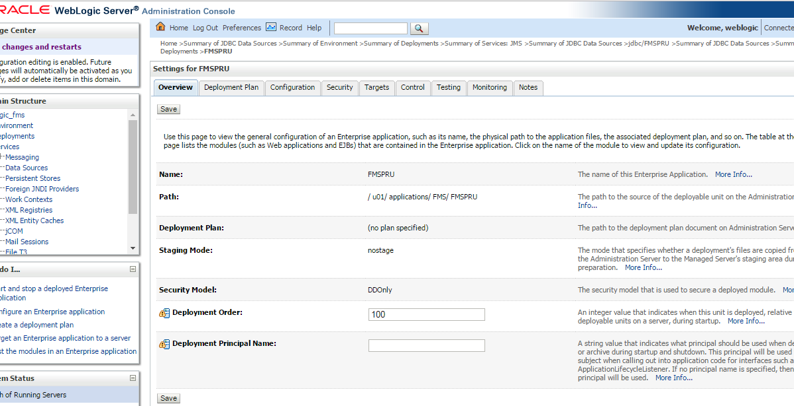

1. The deployment can now be viewed.

